 a) In predicate logic, conflict resolution aims to ensure that logical statements are coherent and consistent, allowing for valid reasoning and inference within the logical system. This process is fundamental to maintaining the integrity and reliability of logical deductions and conclusions.  
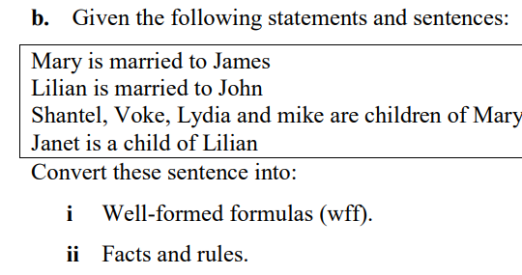  
i)married(mary,james).

married(lilian,john).

mother(mary,shantel,voke,lydia,mike). OR

child(shantel,nmary) ^ child(voke,mary) ^ child(lydia,mary) ^ child(mike,mary).

child(janet,lilian).  
ii)

The characteristics of the Prolog programming language include:  
1. Declarative: Prolog is a declarative programming language, meaning that programs are expressed in terms of logic and relationships rather than explicit sequences of operations.  
2. Logic-based: Prolog is based on formal logic, specifically first-order logic, and uses rules and facts to represent knowledge and relationships.  
3. Rule-based: Prolog programs consist of rules that define relationships and facts that represent specific instances of those relationships.  
4. Backtracking: Prolog uses backtracking to explore alternative solutions when searching for answers to queries, allowing it to find multiple solutions to a problem.  
5. Pattern matching: Prolog uses pattern matching to unify terms and variables, enabling powerful and flexible querying and inference capabilities.  
6. Recursion: Prolog supports recursion as a fundamental mechanism for defining iterative processes and solving problems through self-referential rules.

Elements of a logic language like Prolog include:  
1. Facts: These are statements that are known to be true, representing basic information about the domain being modeled.  
2. Rules: Rules define logical relationships and can be used to derive new information from existing facts and rules.  
3. Queries: In Prolog, queries are used to ask questions or make logical assertions about the relationships defined by the facts and rules.  
4. Variables: Variables are used to represent unknown values and are essential for expressing general relationships and performing logical inference.  
5. Predicates: Predicates are used to define relationships and properties, and they are central to the structure of Prolog programs.  
6. Unification: Unification is the process of finding substitutions for variables that make two terms equal, and it is a key mechanism for reasoning and inference in Prolog. 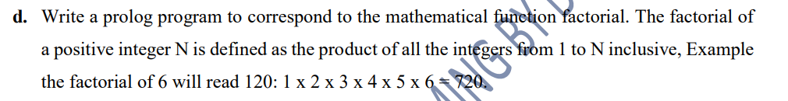factorial(0, 1).

factorial(N, Result) :-

N > 0,

N1 is N - 1,

factorial(N1, Result1),

Result is N \* Result1.

  
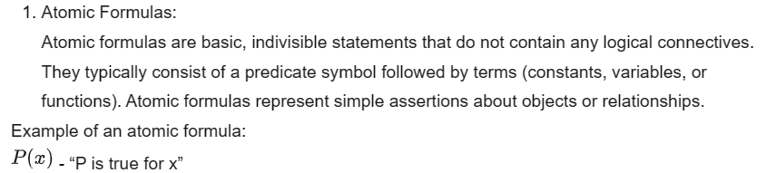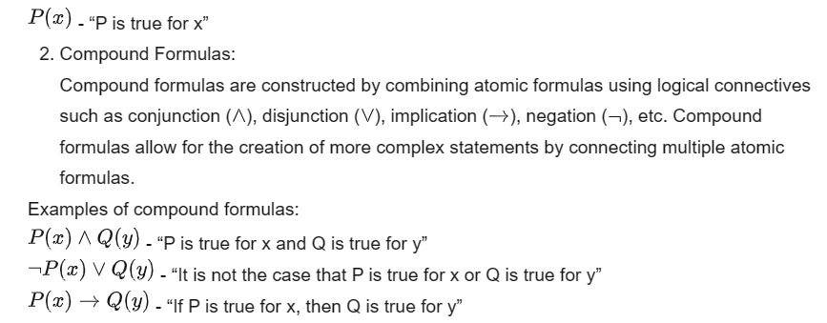

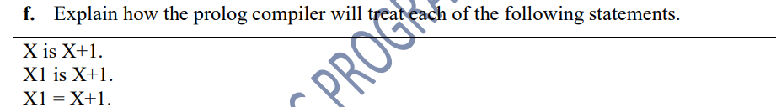

In Prolog, the treatment of the following statements is as follows:

1. `X is X+1.`:

- This statement is an arithmetic computation. It attempts to evaluate the expression on the right-hand side and unify it with the variable on the left-hand side. However, in Prolog, the expression `X+1` is not evaluated as an arithmetic operation; instead, it is treated as a structure. Therefore, this statement will not perform arithmetic addition but rather attempt to unify the variable X with the term X+1.

2. `X1 is X+1.`:

- Similar to the previous statement, this is also an arithmetic computation. It attempts to evaluate the expression on the right-hand side and unify it with the variable X1 on the left-hand side. Again, the expression `X+1` is treated as a structure, and the result will depend on the current values assigned to X and X1.

3. `X1 = X+1.`:

- This statement is a unification. It attempts to unify the term on the left-hand side with the term on the right-hand side. In this case, it tries to unify the variable X1 with the term X+1. This does not perform any arithmetic computation; it simply checks if the terms can be made equal through unification.  
Goal-Driven System:

* A goal-driven system focuses on achieving a specific objective or goal

Data-Driven System:

* A data-driven system, on the other hand, emphasizes the use of available data to derive insights, patterns, or conclusions.

h. Write a prolog program to reverse the elements of a list.

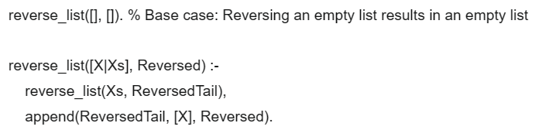



  
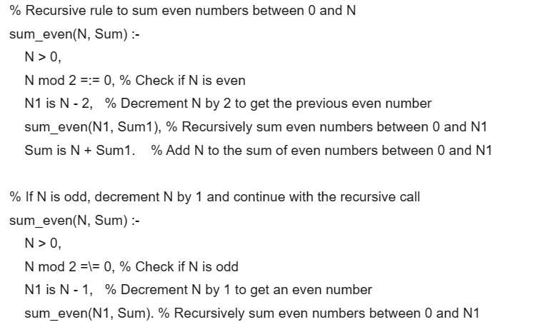

k. What is first order logic?

First-order logic (FOL), also known as first-order predicate logic, is a formal system used in mathematics, philosophy, linguistics, and computer science to express statements about objects, their properties, and relationships.

1.Syntax validity refers to whether a program follows the correct grammar and structure of the programming language.

1. Semantic Validity:

Semantic validity refers to whether a program has a meaningful interpretation or complies with the intended semantics of the language.

m. Define the following concepts as used in the study of PROLOG: i. Binding Variables: process of associating a variable with a specific value or term during the execution of a program.   
ii. Backtracking: : mechanism in Prolog that allows the system to explore alternative solutions when trying to satisfy a goal.   
iii. Cut function: used to control backtracking and prune the search space by committing to the choices made before the cut.  
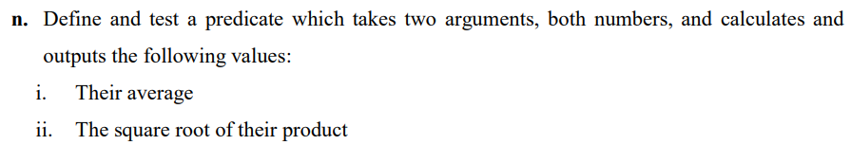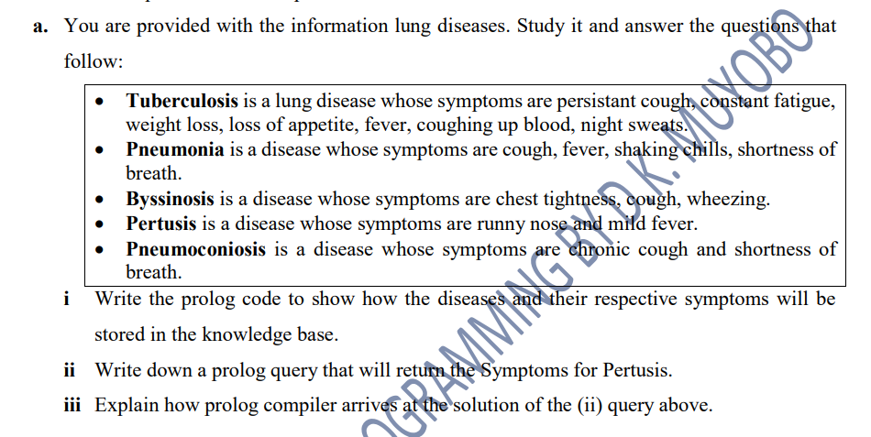

A knowledge representation language needs to fulfill several requirements:

1. Expressiveness: The language should be able to represent a wide range of knowledge and information, including concepts, relationships, rules, and constraints.

2. Inferential capabilities: It should support reasoning and inference mechanisms to derive new knowledge from existing knowledge.

3. Formal semantics: The language should have well-defined and unambiguous meanings for its constructs, allowing for precise interpretation and manipulation by automated systems.

4. Efficiency: The language should allow for efficient storage, retrieval, and manipulation of knowledge, especially in the context of automated reasoning systems.

5. Modularity: It should support the organization of knowledge into modular and reusable components, facilitating the management and maintenance of complex knowledge bases.

6. Ontological support: The language should provide mechanisms for defining and using ontologies to capture domain-specific concepts and their interrelationships.

7. Scalability: It should be capable of handling large and complex knowledge bases, accommodating growth and evolution over time.

8. Interoperability: The language should enable integration with other systems and languages, allowing for seamless exchange and sharing of knowledge across different platforms and domains.